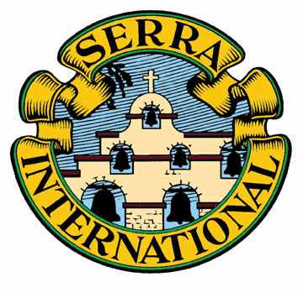
Serra
Leadership Training & Club Planning
2018

Session 1: The Big Picture (above the Club)
Serra International—Mission, St. Serra, History, Organization, Financials, & Value
Serra Foundation—Mission & recent grants
Serra US—Structure & Organization, Financials, Value & Current Focus
Serra Dues Structure
Serra in Iowa—membership by club and seminarians by diocese
U.S. Vocations—The Big Picture

Meeting Options:
Tuesday, April 10,2018 @ 7:00 – 8:30 pm
Wednesday, April 11, 2018 @ 7:00-8:30 pm

Session 2: How Clubs Work & Event/Planning Calendar for 2018-2019

Meeting Options:
Tuesday, April 17, 2018 @ 7:00 – 8:15 pm
Wednesday, April 18, 2018 @ 7:00-8:15 pm

Session 3: Vocations Activities/ Serra Spark & Monthly Programs

Meeting Options:
Tuesday, April 24, 2018 @ 7:00 – 8:30 pm
Wednesday, April 25, 2018 @ 7:00-8:30 pm

Session 4: Membership & Communications Efforts

Meeting Options:
Tuesday, May 1, 2018 @ 7:00 – 8:15 pm
Wednesday, May 2, 2018 @ 7:00-8:15 pm

Session 5: Treasurers Function & the Serra Web Portal

Meeting Options:
Tuesday, May 8, 2018 @ 7:00-7:45 pm
Wednesday, May 9, 2018@ 7:00-7:45 pm

How to Connect:
To join the training session from your computer, tablet or smartphone:
(1) go to gotomeeting.com (2) Click the “Join A Meeting” button (3) enter 331841333 in the meeting ID (first time users see following page)
OR you can dial in using your phone (no video):
United States: +1 (646) 749-3112 Access/Meeting Code: 331-841-333

